Rendell Y4 Reading Spine 

Links to WCR Texts
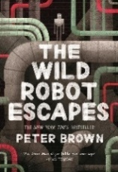 | The Wild Robot Escapes  Peter Brown | 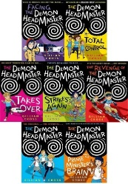 | The Demon Headmaster  (series)
 | The Wild Robot Protects |  | The Demon Headmaster  (series)
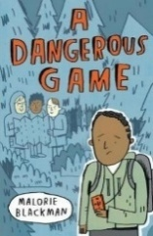 | A Dangerous Game  Malorie Blackman | 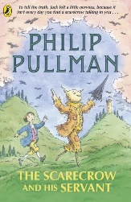 | The Scarecrow and His Servant  Philip Pullman
 | Peace Maker |  | The Scarecrow and His Servant  Philip Pullman
Links to Previous Years
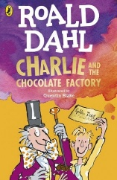 | Charlie and the Chocolate Factory  Roald Dahl | 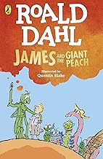 | James and the Giant Peach  Roald Dahl
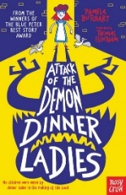 | Attack of the Demon Dinner Ladies  Pamela Butchart | 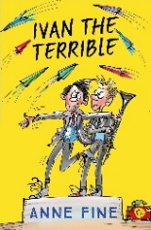 | Ivan The Terrible  Anne Fine
 | There’s a Werewolf in my Tent |  | Ivan The Terrible  Anne Fine
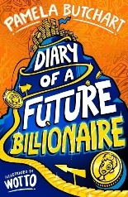 | Diary of a Future Billionaire  Pamela Butchart | 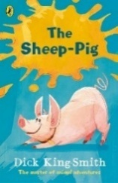 | The Sheep-Pig  Dick King Smith
 | Diary of a Future Billionaire  Pamela Butchart |  | The Hodgeheg
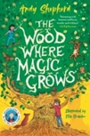 | The Wood Where Magic Grows  Andy Shepherd | 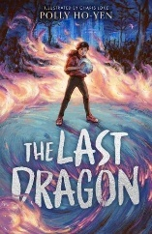 | The Last Dragon  Polly Ho-Yen
 | The Wood Where Magic Grows  Andy Shepherd |  | When the Storm Comes
New Authors/Texts
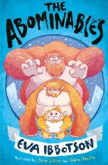 | The Abominables  Eva Ibbotson | 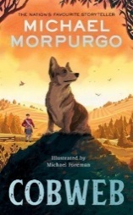 | Cobweb  Michael Morpurgo
 | One Boy and his Dog |  | The Dancing Bear  The Butterfly Lion
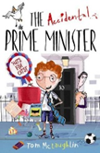 | The Accidental Prime Minister  Tom McLaughlin | 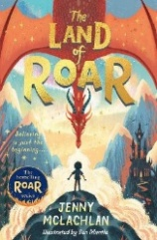 | The Land of Roar  Jenny McLachlan
 | The Accidental…  (series) |  | Return to Roar  Battle of Roar  Dragon Riders of Roar
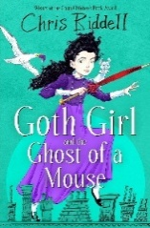 | Goth Girl and the Ghost of a Mouse  Chris Riddell | 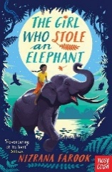 | The Girl who Stole an Elephant  Nizrana Farook
 | Goth Girl (series) |  | The Boy Who Met a Whale  The Girl Who Lost a Leopard  The Boy Who Saved a Bear
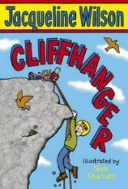 | Cliffhanger  Jacqueline Wilson | 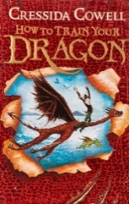 | How to Train Your Dragon  Cressida Cowell
 | Buried Alive! |  | How to Train Your Dragon  (series)
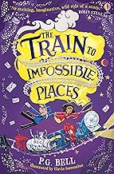 | The Train to Impossible Places  PG Bell | 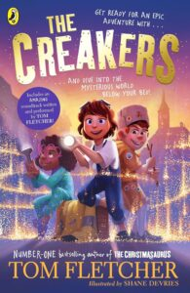 | The Creakers  Tom Fletcher
 | The Beanstalk Murder |  | The Danger Gang  Space Band
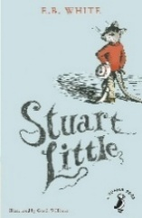 | Classic  Stuart Little  E.B. White | 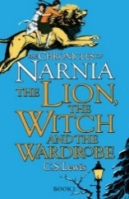 | The Lion, the Witch and the Wardrobe  C.S. Lewis
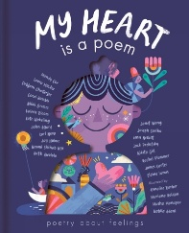 | My Heart is a poem  Poetry Anthology | 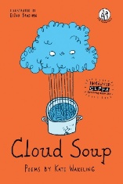 | Cloud Soup  Kate Wakeling

